|  |  |
| --- | --- |
| **NOIS**  *the results complaints application* | DESCRIPTION  *The results complaints app is called NOIS. It enables lecturers to submit results (Course work/final mark) against each course unit the students have registered for. If a student is not satisfied with their results, he or she submits a complaint, the app tracks it and then receives a CASE Tracking Number. The complaints submitted can be approved by the AR and HOD after which the results will be rectified by the lecturer depending on the courses he or she teaches.in case the complaints are not approved by the AR, a student can appeal directly to the HOD. The students can at any time also check the status of the complaint by using the CASE Tracking Number. The case status can change on submission of the case, upon approval by AR, upon approval by HOD, upon approve entry of the result by lecturer, upon approval of result by HOD and upon rejection by HOD/AR and the students receive email alerts upon each status change.*  user |

**PROJECT THEME: A Web Application**

**PROJECT MEMBERS**

|  |  |  |
| --- | --- | --- |
| NAME | REGISTRATION NUMBER | STUDENT NUMBER |
| ANKUNDA ANDANTE RUTAINAMA | 20/U/2015/EVE | 2000702015 |
| NIWAHEREZA SIMON DESIRE | 20/U/7803/PS | 2000707803 |
| MUGISA BRIAN | 20/U/7823/PS | 2000707823 |

**PROJECT TITLE: RESULTS COMPLAINTS MANAGEMENT SYSTEM**

1. **INTRODUCTION**

With the increasing number of students in the university, the office of the academic registrar has suffered with overwhelming numbers of students who come to make various complaints concerning their results. This has resulted into delays experienced by the students because of the few members of staff in the academic registrar’s office.

1. **PROBLEM STATEMENT**

Unnecessary delays experienced by students due to the few staff members in the academic registrar’s office who are supposed to help the students rectify their problems with marks.

1. **BACKGROUND OF THE PROBLEM**

Different students have visited the academic registrar’s office, my friends and I personally visited the office early in the morning and as soon as we had reached the office, we had to queue for about two hours because of the overwhelming numbers that were there but as we were waiting, we thought about an idea where a student can submit their complaint online and their complaint is worked on very fast. This led to the whole idea of the NOIS application.

1. **MAIN OBJECTIVE**

The main goal of this study is to develop a web based results complaints management application called NOIS which helps the students to submit complaints if they are not satisfied with their marks in the different course units at their time of convenience.

* 1. **Specific Objectives**:
* To study the existing system and define requirements for NOIS application which helps students to submit their complaints if they are not satisfied with their marks in the different course units.
* To design the model for the web-based results complaints application.
* To implement the web-based results complaints application.
* To test and validate the web-based results complaints application.

**ACRONYMS DEFINITION**

* AR-*Academic Registrar*
* HOD-*Head of Department*

1. **SYSTEM DESIGN**

**5.1 USE CASE**

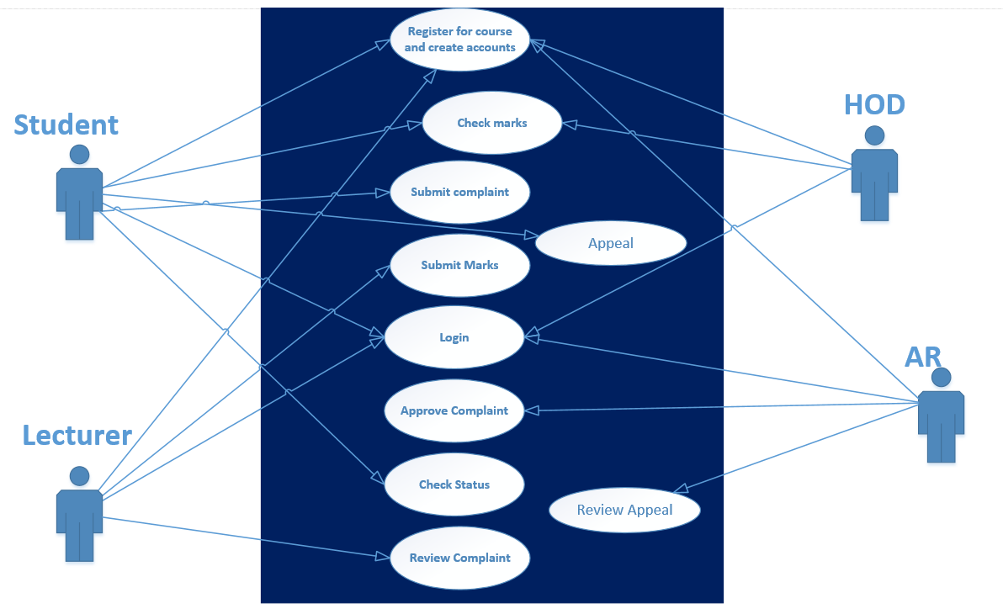

* 1. USER INTERFACE

**INDEX PAGE**

1. **Home**

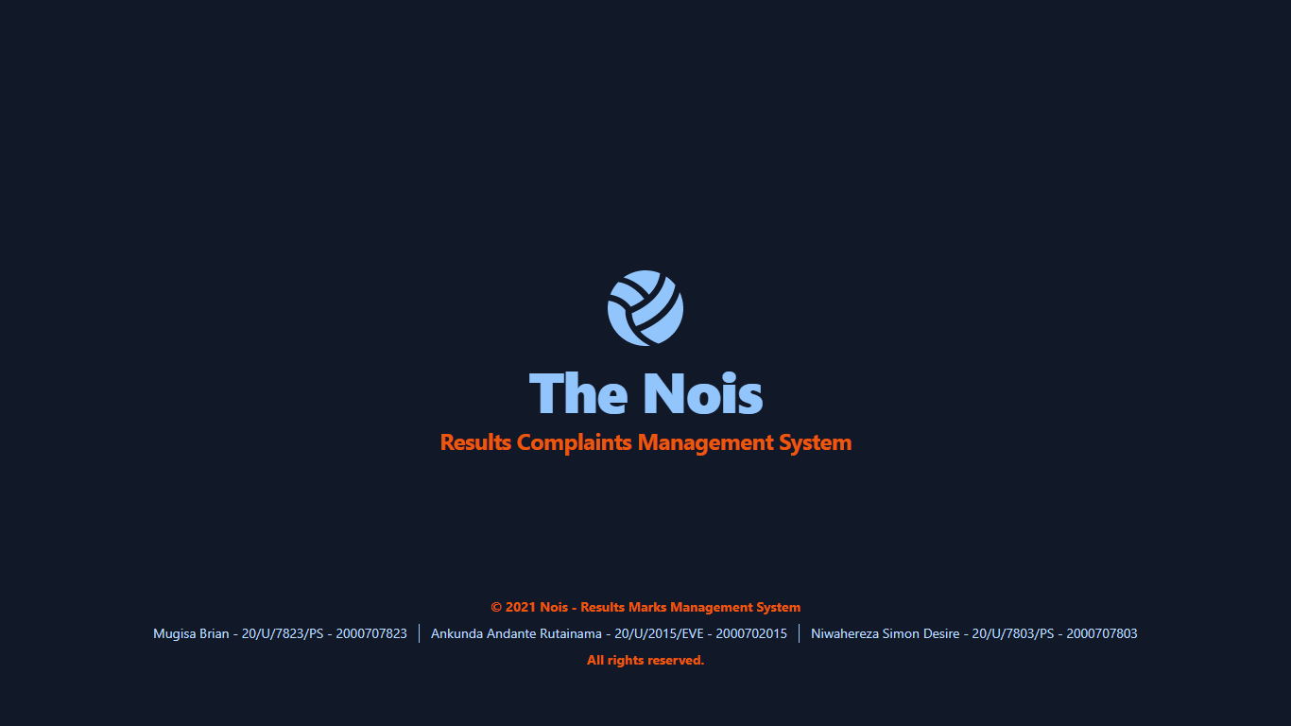

1. **Dashboard**

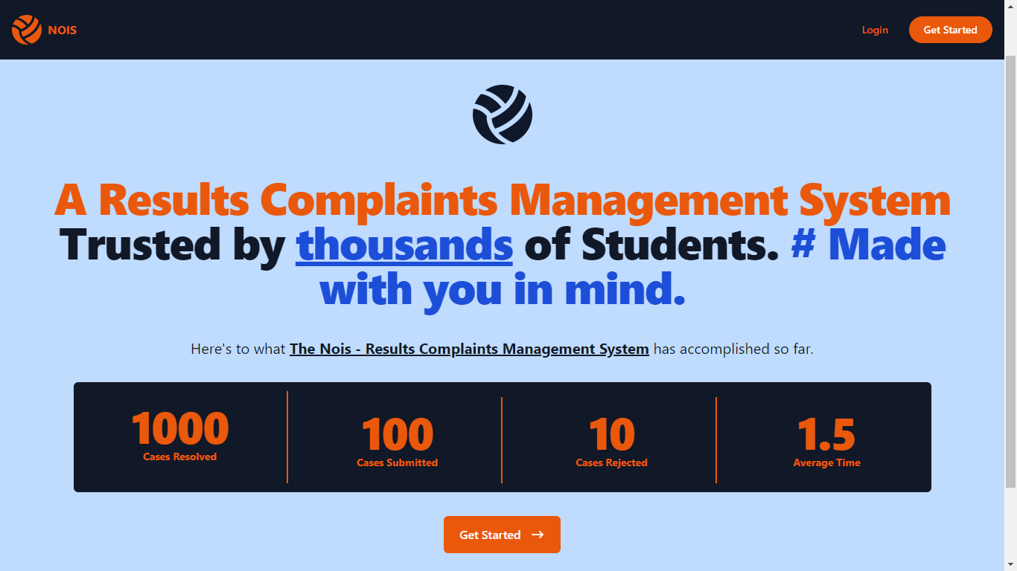

**STUDENT LOGIC**

1. **Home**

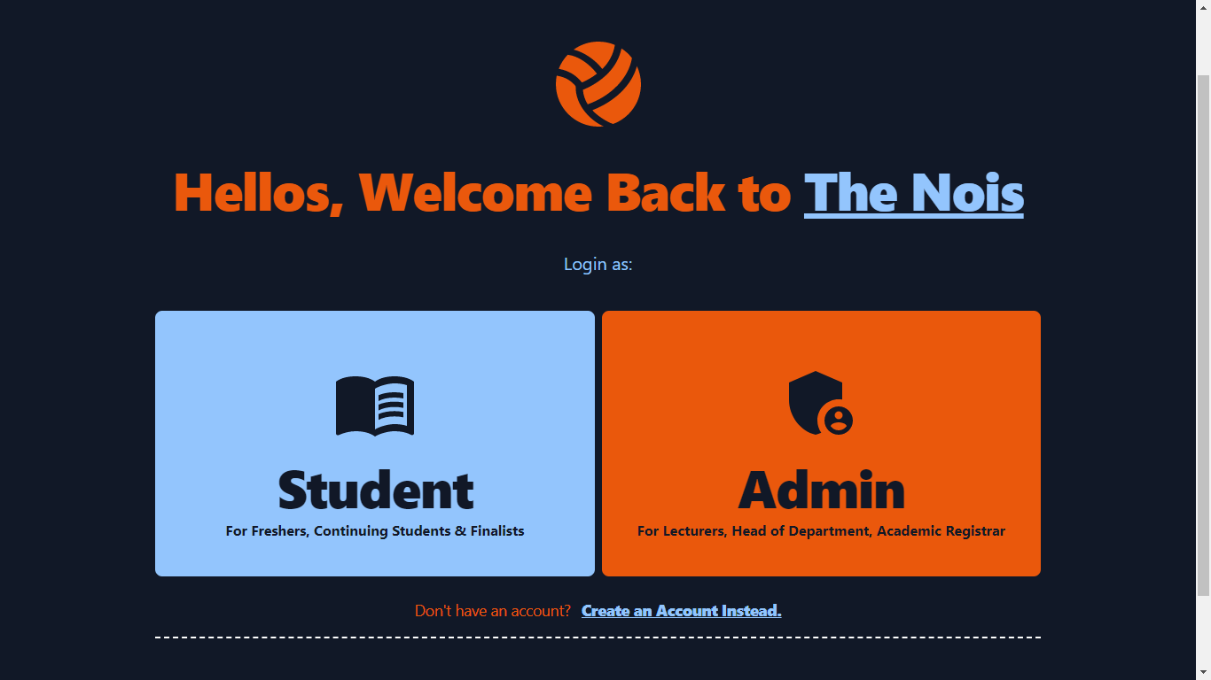

1. **Register**

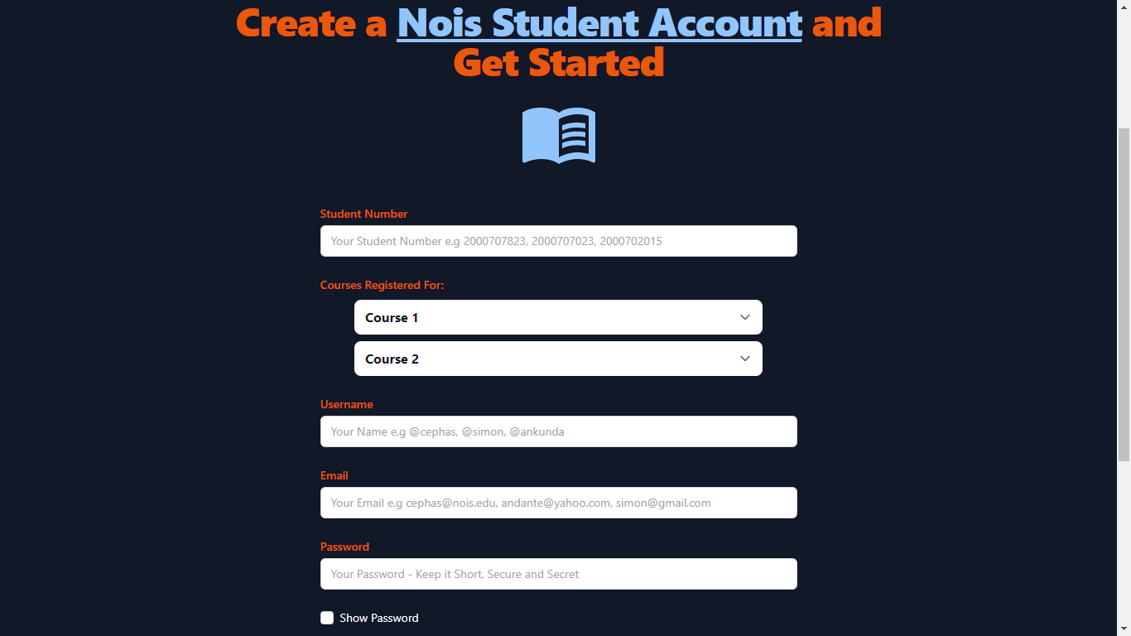

1. **Login**

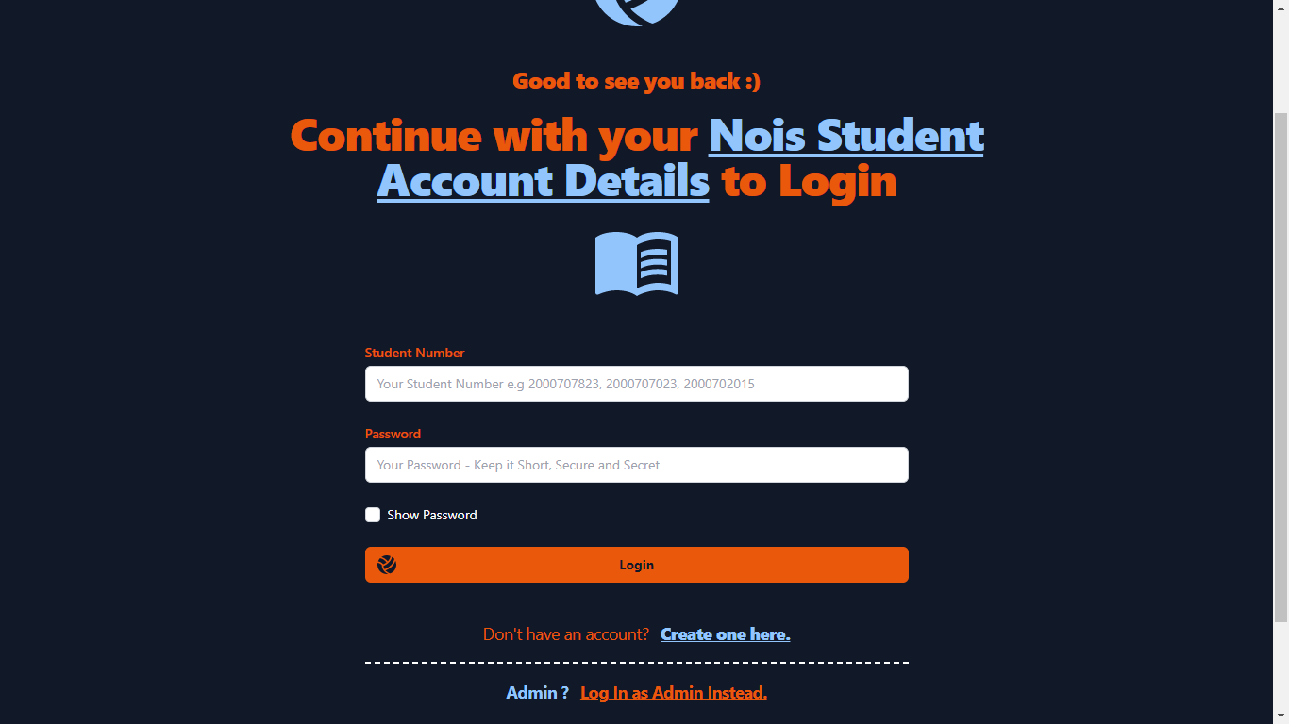

1. **Add Complaint by Student**

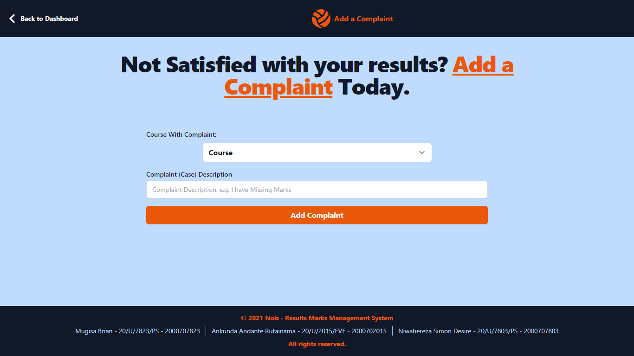

**ADMIN: HOD, LECTURER, AR**

* **Dashboard**

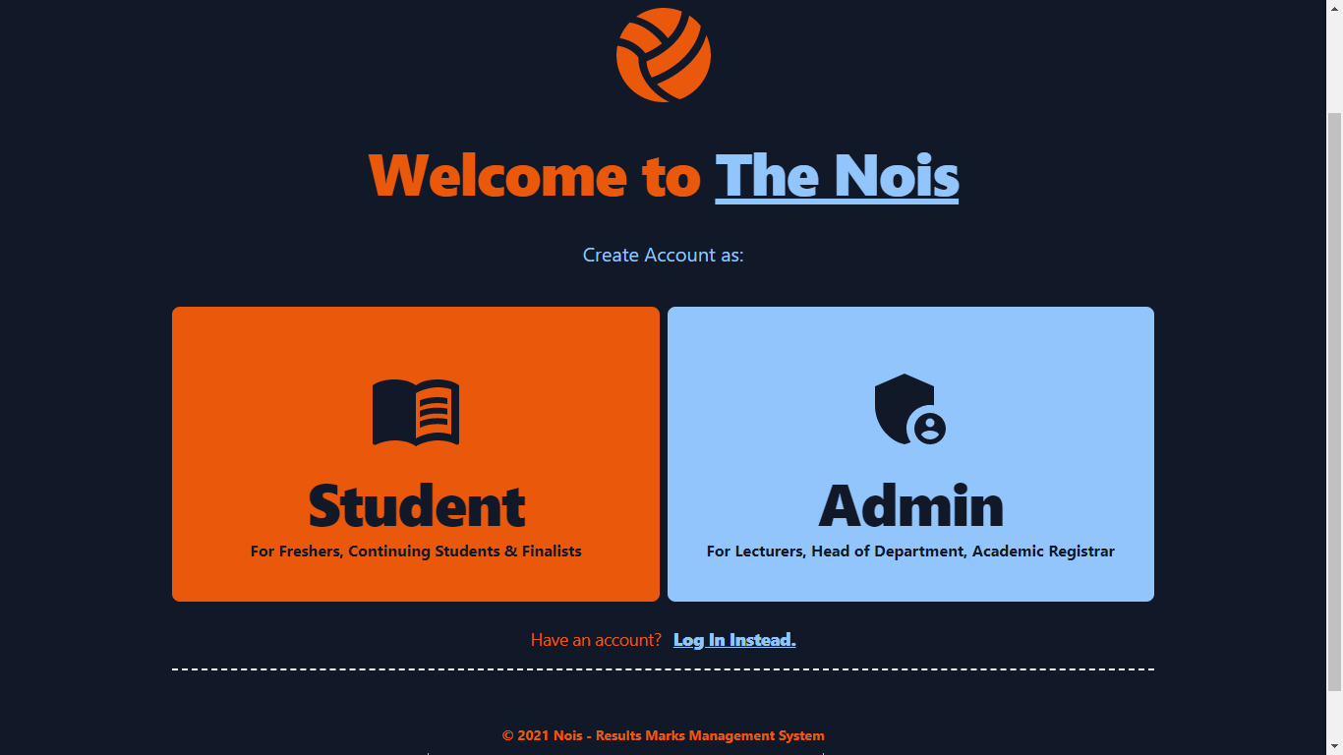

* **Register**

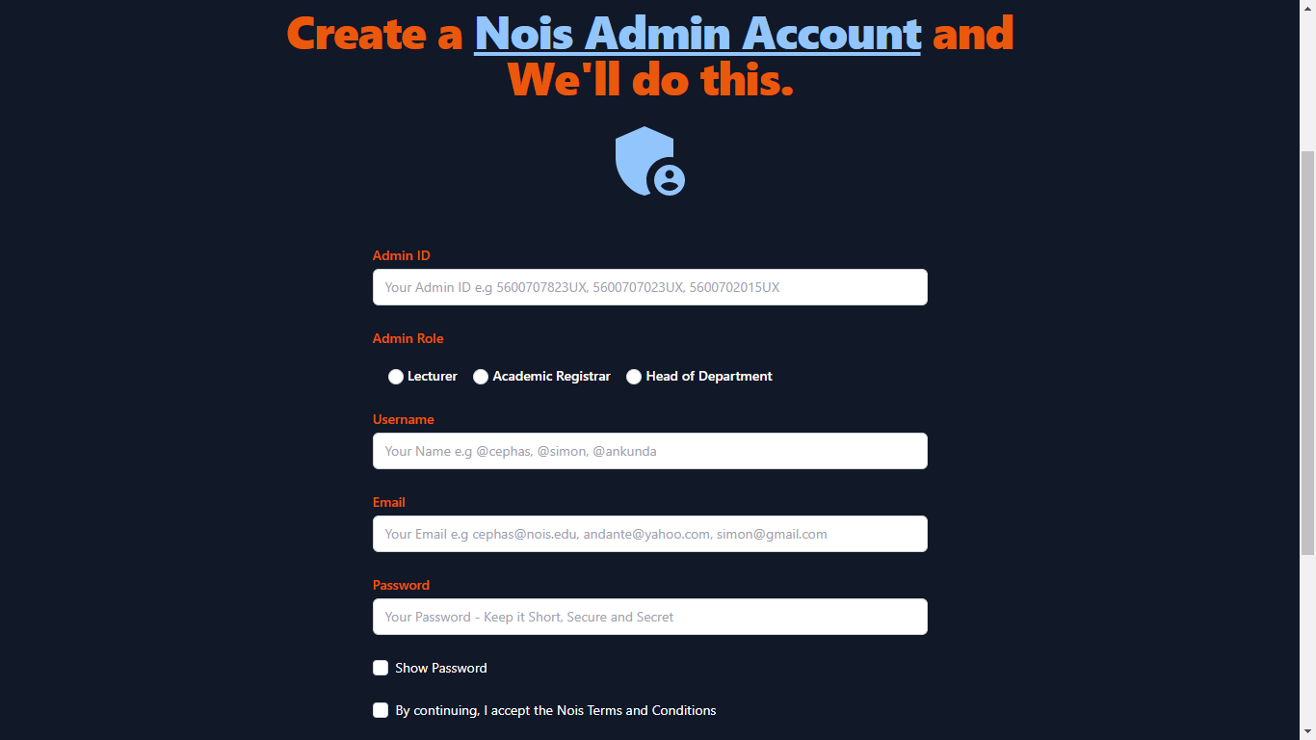

* **Login**

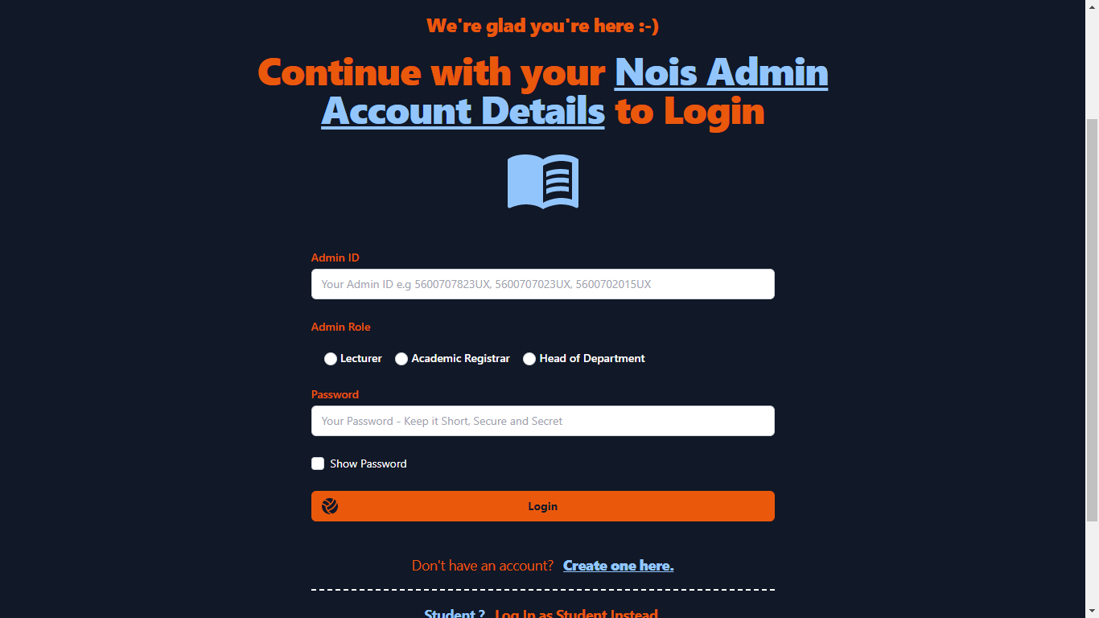

* **Add Student Marks by Lecturer**

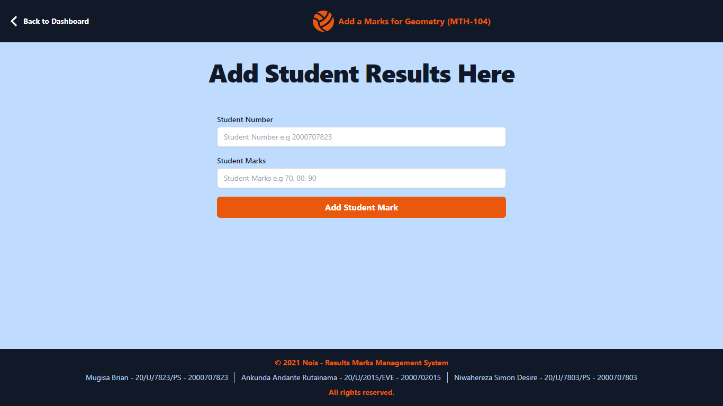

**COMPLAINTS VIEWS**

* **HOD**

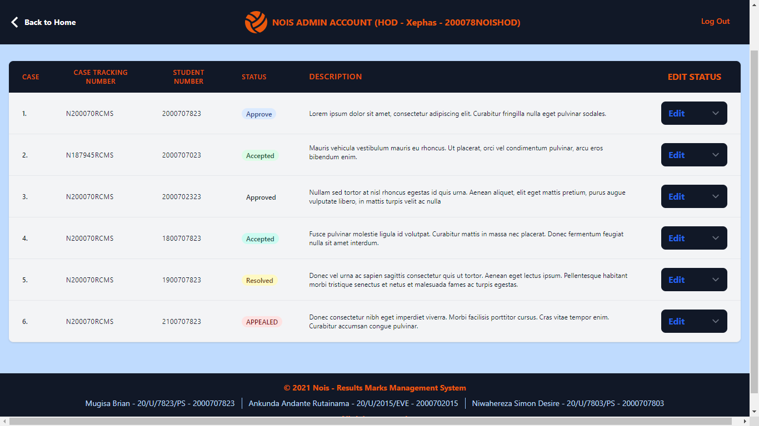

* **AR**

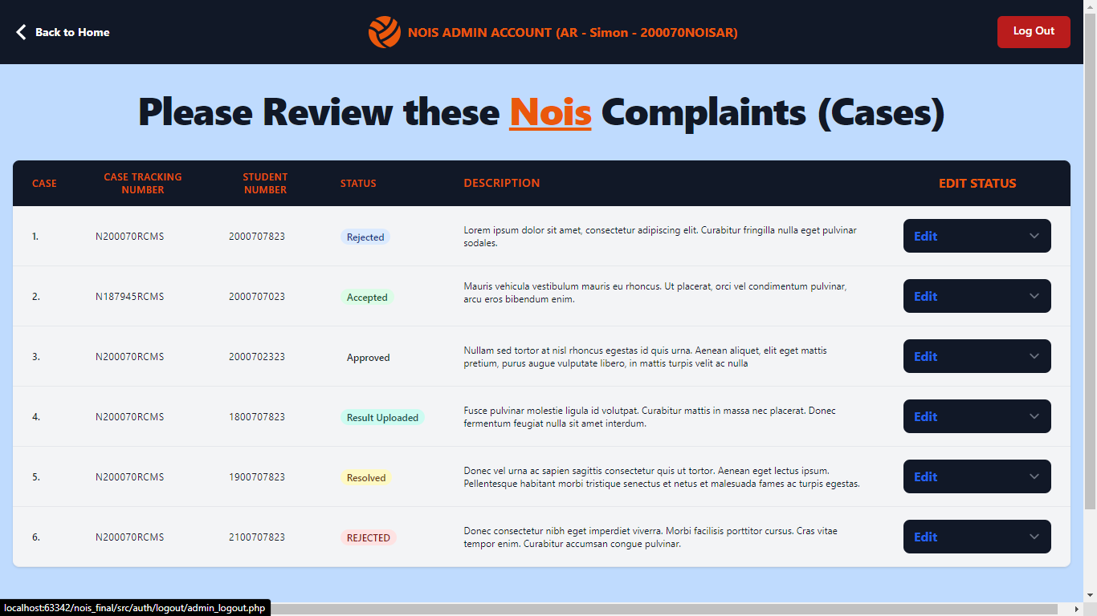

* **LECTURER**

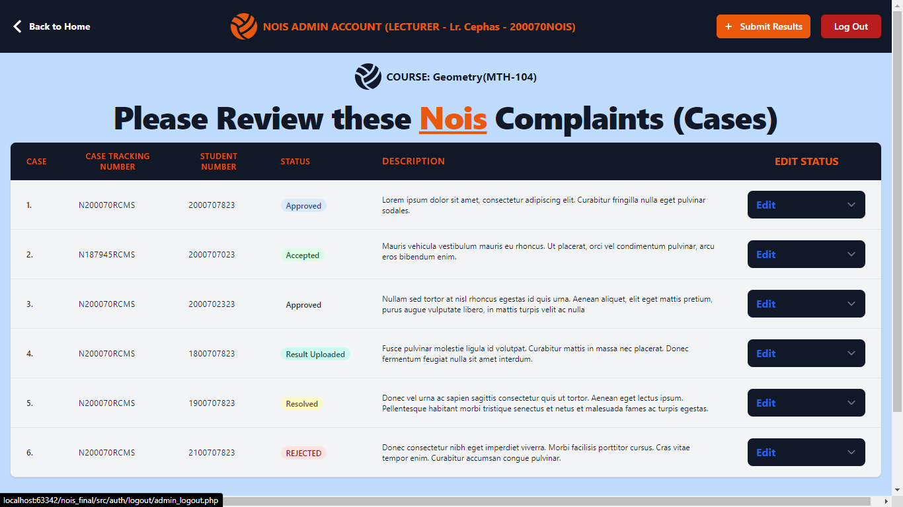

* **STUDENT**

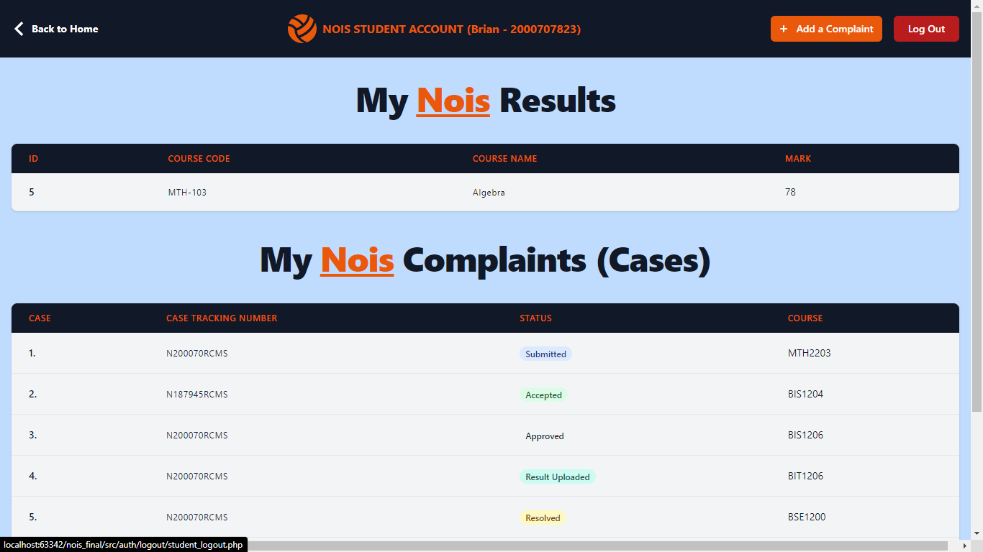

1. **SCOPE OF THE STUDY**
   1. **Geographical Scope**

This study was carried out in the various colleges of the university: COCIS, CHUSS, CEES, COBAMS where there are many students.

* 1. **Theoretical Scope**

This study entailed developing the application with multi-user views, one for the students and the other for admin which includes the lecturers, AR, HOD.

1. **RESEARCH SIGNIFICANCE**

At the end of the project, the results complaints application will be of importance in the following ways;

* Upon submission of a complaint, the application tracks it and a student is given a CASE Tracking Number.
* The submitted complaints can be approved by the AR and HOD after which the results are rectified by the lecturer depending on the courses he or she teaches.
* In case the complaints are not approved by the AR, a student can appeal directly to the HOD.
* The case status can change on submission of the case, upon approval by AR, upon approval by HOD, upon approve entry of the result by lecturer, upon approval of result by HOD and upon rejection by HOD/AR.
* Once the application is completed, the students will be sent email alerts upon each status change.

1. **METHODOLOGY**
   1. **Introduction**

This section gives a description of the methods, techniques, tools that will be used to achieve the specific objectives of the research study. These methodologies will be employed in the research study, data collection, analysis, design, implementation, testing and validation of the system.

The table below shows different methodologies, tools and deliverables to be used when developing the web-based results complaints application

|  |  |  |
| --- | --- | --- |
| **OBJECTIVE** | **TOOL/TECHNIQUE** | **DELIVERABLE** |
| To study the existing system and define requirements for NOIS application which helps students to submit their complaints if they are not satisfied with their marks in the different course units. | Interviews, questionnaires | System requirements specification document |
| To design the model of the application | Microsoft Visio to come up with ERDs | System design document |
| To implement the application | JavaScript, Tailwind CSS | Prototype for the system |
| To test and validate the application | Experiments | Complete functioning system |

1. **SOFTWARE REQUIREMENTS SPECIFICATIONS**

This describes what the software will do and how it will be expected to perform. It also describes the functionality the product needs to fulfill all the business, user needs.

* 1. **External Interfaces. (home screen)**
  2. **Functions (this describes what our system does to solve the problem)**
* System inputs
* System processes
* System outputs
  1. **Usability requirements (specifies how easy the system must be easy to use)**
* **Ease of learning.**

The system will be easy to learn because we have put in place a user-friendly interface that will not require additional skills.

* **Ease of remembering.**

The system will be easy to remember for casual users.

* **Understandability.**

The user shall be able to understand what our system does i.e. not to be able to find difficulty in using our system.

* **Subjective satisfaction.**

The user of our system must be able to feel satisfied with the system.

* **Task efficiency.**

The system shall be efficient for the frequent user.

* 1. **Performance requirement**

This defines how well the system performs functions under specific conditions.

* **Error rate**

The system shall define the acceptable error rate allowed during the measurement of the response times.

The system shall avoid any form of ambiguous

* **Service requirements**

A section of the system will only be accessed by authorized users for example the manager shall be able to view the daily business transaction processes.

* 1. **Logical database requirements**
  2. **Design constraints**
  3. **Software system attributes**
* **Reliability**

The system should give consistently correct results

* **Maintainability**

This defines the suitability for debugging, modification and extension of functionality

* **Usability**

This can be measured in terms of ease of use.

1. **SYSTEM DESIGN**
2. **Use Case Diagram**

**10.00 CHALLENGES FACED DURING THIS PROJECT**

* Integration of new languages and frameworks like PHP Laravel in the project.
* Limited time for the project.
* Ambiguous requirements from the users of the application.

1. **LESSONS LEARNED**

* We learned how to team up and come up with a project with teamwork.
* We learned to make research from different places to come up with something workable.